AFC RUSHDEN & DIAMONDS EXTRAORDINARY NEWSLETTER
13 FEBRUARY 2015

One Fan, One Vote, One Community, One Club

We bring you this extraordinary Newsletter to inform that today we launch


Do you want a chance to win £2,000 every week and help your football club at the same time? Well Read on!
AFC Rushden and Diamonds are delighted to announce the launch of its GOLD BOND Lotto.
This is a weekly lottery, twinned with other schemes across the country, where by paying JUST £1 a week you will be in with a chance of winning £2,000 and over 300 smaller prizes.
The Lotto has been running for many years, and is made up from other football clubs across the country, from the championship through to non-league.
AFC Rushden & Diamonds will benefit by receiving a percentage of the stake, and you could receive the rest if you are one of the many winners.
INTERESTED? Well there are lots of ways to get involved.
The easiest way is to sign up HERE
http://wwwgoldbondlotto.com/?ref=RUSH
Follow the onscreen instructions

You can enter once for £1 per weekly draw, or double up your chances by staking just £2 per week.
Once you have registered THAT’S IT! Your entry will be retained. You will then receive 7 unique numbers, which hopefully will be drawn out in one of the weekly prize draws.
Alternatively, at the next match, you can see Mark Cullen (goldbond@afcdiamonds.com) or James Waller (james.waller@afcdiamonds.com) who will be able to give you a form to set up a standing order. Please bring bank details with you!
So if you want to help your football club, and stand a chance of winning £2,000 each week follow this link http://wwwgoldbondlotto.com/?ref=RUSH and be in it to win it while helping your club

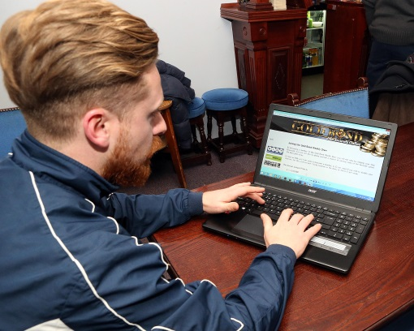
Matt Gearing celebrates his 100th appearance by backing GOLD BOND, ‘It’s a great idea, if everyone gets involved, what a boost this could be for the club’

Chairman Ralph Burditt is looking forward to the launch; he was the first to sign up, before the link had even gone live.
‘"The Gold Bond scheme is a great way to raise money for the club whilst also giving yourself the chance of winning cash prizes.
As a Community Club, fundraising efforts such as this one are a vital part of our income and by signing up you'll be making an important contribution to our success."
Ralph Burditt
Want more Info? Contact
goldbond@afcdiamonds.com
The Gold Bond Weekly Draw
Supporting AFC Rushden & Diamonds
Gold Bond has been in operation now for over 20 years and currently works with 30 clubs
With a weekly £2,000 jackpot
As well as
1 x £500, 1 x £200, 2 x £100, 4 x £50, 6 x £25,
170 x £10 and 130 x £5
Massive annual £10,000 jackpot prize!
Sign up and support your club
Be in it to win it
www.goldbondlotto.com/?ref=RUSH
Want more Info? Contact
goldbond@afcdiamonds.com

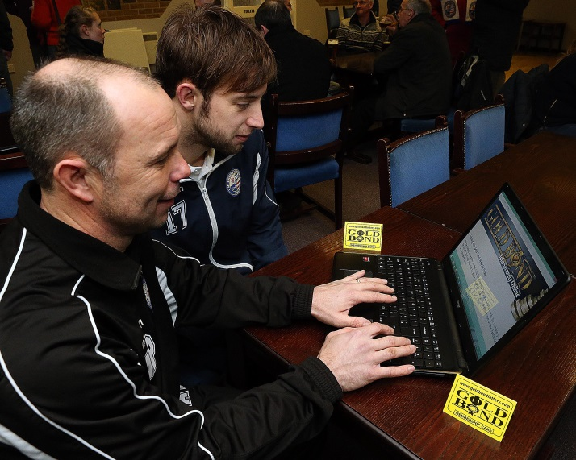
First team manager Andy Peaks is eager to help, and sees the huge potential of GOLD BOND
“I’m more than happy to help and get people on board, it’s a great scheme, benefits us all long term”

Our club secretary looks at the wider view
So the question is, why bother? What are the benefits to joining this scheme? Well first and foremost, you are entering yourself into a weekly draw where you have a chance of winning £2,000, as well as over 300 other cash prizes.

However, this scheme is broader than that. For every £1 entry AFC Rushden & Diamonds will receive over 55p, which we can use to support our 34 teams across age groups from Under 9s right up to the first team.

As many of you will know, we are currently searching for an appropriate area of land in which to base our new stadium. Once this is identified, we hope to be able to create a community hub, to enable us to host every single one of our teams. Most importantly, however, is that we are looking to address a critical shortage of leisure facilities for the young people in the trio of towns making up "Rushdenshire" of Rushden, Higham Ferrers and Irthlingborough. Currently 90% of our sides play outside of this area, with some having to travel as far as Northampton to play their home games.

GOLD BOND money will enable us to plan for when a site is determined, and to ensure that we are able to lobby the council to ensure that sufficient facilities are in place.

As also mentioned, we currently have 34 teams, but we want more! One area of development which we hope to look towards is in girls and women's football. As a community based club we believe it is critical to ensure "participation for all", and developing our girls section is crucial to this vision. You money will be used to ensure that this, by ensuring that pitches are available and of a suitable standard.

We also feel that good quality coaching is something that is crucial to not only to the development of future AFC Rushden & Diamonds players, but also for players nationally, and this is something we hope to use funds from this initiative to work towards.
Currently, we have a number of dedicated coaches and parents who have stepped up to help out a number of teams as coaches, and they are doing a fantastic job.
With GOLD BOND funds we hope to be able to help them to do even better. Money from this initiative will be used to fund current coaches to further their coaching qualifications, and gain insight from coaches in other teams.

So, I hope this answers the question of why bother.

We hope to use any funds to create a legacy for our club, to ensure that all of our community players have the best facilities available, and to have the best coaching possible.

James Waller

Sign up today, be in it, to win it and at the same time let’s make our club even stronger

Want more Info? Contact
goldbond@afcdiamonds.com
One Fan, One Vote, One Community, One Club
WHAT OTHER WAY COULD YOU GET INVOLVED I HEAR YOU SAY?

Agents & Canvassers required

Up to 20% commission on your members every week

A Free season ticket

Sign up bonuses

10 % Agent’s bonuses on winners
Let’s team up and make this scheme a winner

Want more Info? Contact
goldbond@afcdiamonds.com
GOLD BOND
www.goldbondlotto.com/?ref=RUSH
Promoter: J. Woodman. Freepost BJ2683, Blackpool, FY1 1ZR

The Gold Bond Weekly Draw is used by a variety of sporting organisations and/or charities to generate income.
Licenced by The Gambling Commission. Licence 5166 Member of the Lotteries Council Please gamble responsibly – www.gamcare.co.uk

